**TRADITIONAL METHOD**

1)x’’’=3*u(t) – 2*x’’-4*x’-2*x

Given: x’(0)=1, x’’(0)=2, x’’’(0)=3

**SIMULINK MODEL**

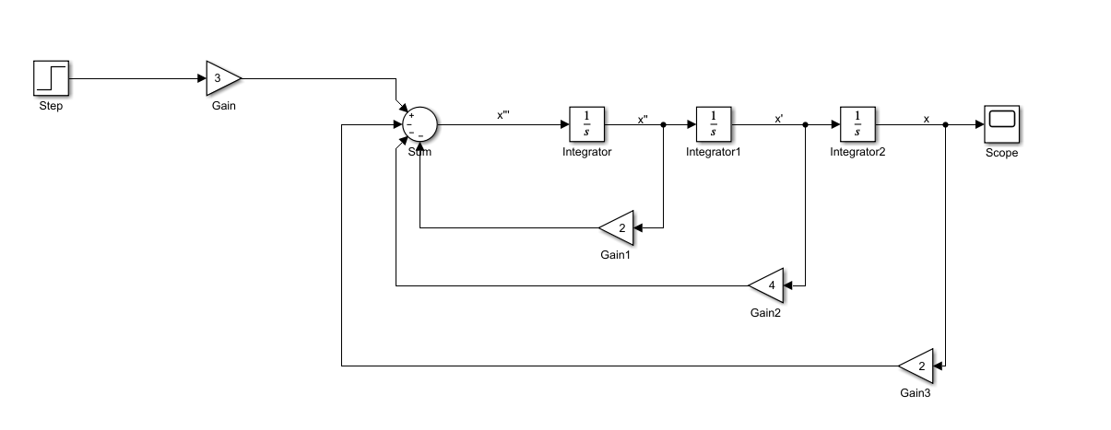

**GRAPH**



**MATRIX METHOD**

2) 3*x’’’=9*u(t) – 6*x’’-12*x’-6*x

Given: initial condition=0

**SIMULINK MODEL**

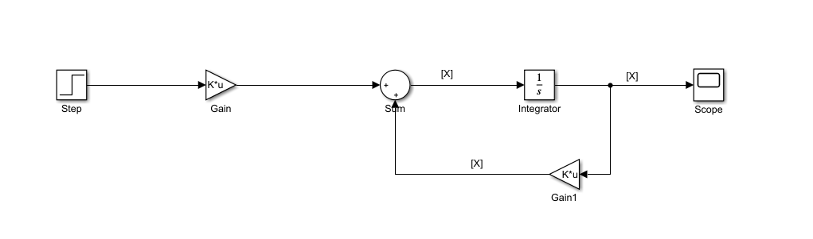

**GRAPH**



**MATRIX METHOD**

3) 2*x’’’+5*x’’+9*x’+3*x=3*u(t)

Given: initial condition=0

**SIMULINK MODEL**

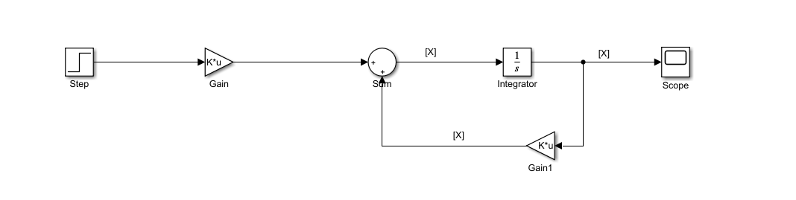

**GRAPH**

